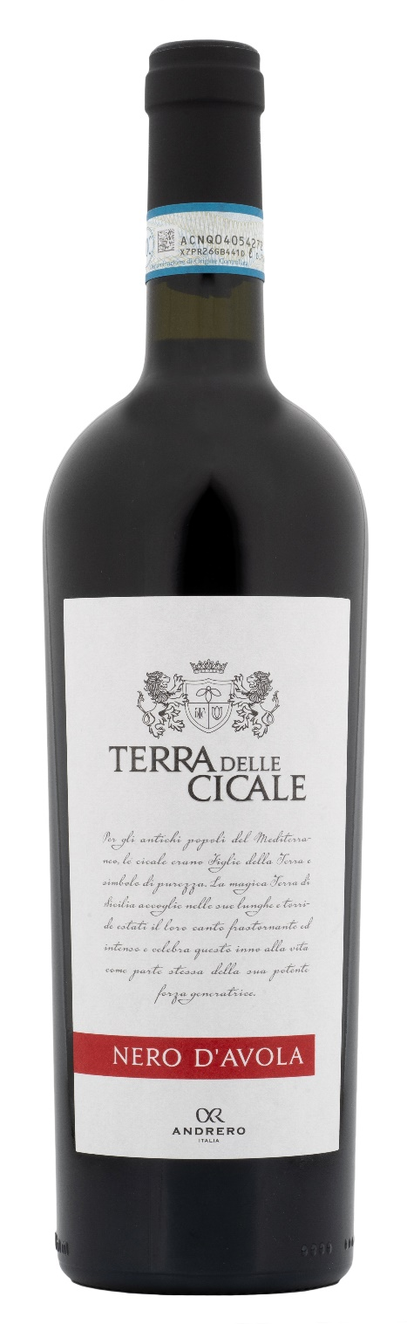
NERO D’AVOLA DOP – TERRA DELLE CICALE

Grape: Nero d’Avola 100%
Alc. Vol.%: 13,5
Vintage: 2023
Residual sugar g/l: 6,0
Total acidity g/l: 5,9
Region: Sicily
Production zone: Vineyards in the provinces of Trapani and Caltanissetta
Capacity: 750ml, 1500ml

CHARACTERISTICS

Vinification: Traditional peel maceration at a controlled temperature
Aging: 8 months in steel tanks
Yield per ha: 12000kg
Colour: Intensive red with purple reflections
Bouquet: Intense aromas of cherry, ripe fruits and jam
Flavour: Full-bodied, balanced, with a long-lasting finish

SERVING SUGGESTIONS

Best enjoyed with tasty pasta courses, red meat and cheese.
Serving temperature 16-18 °C
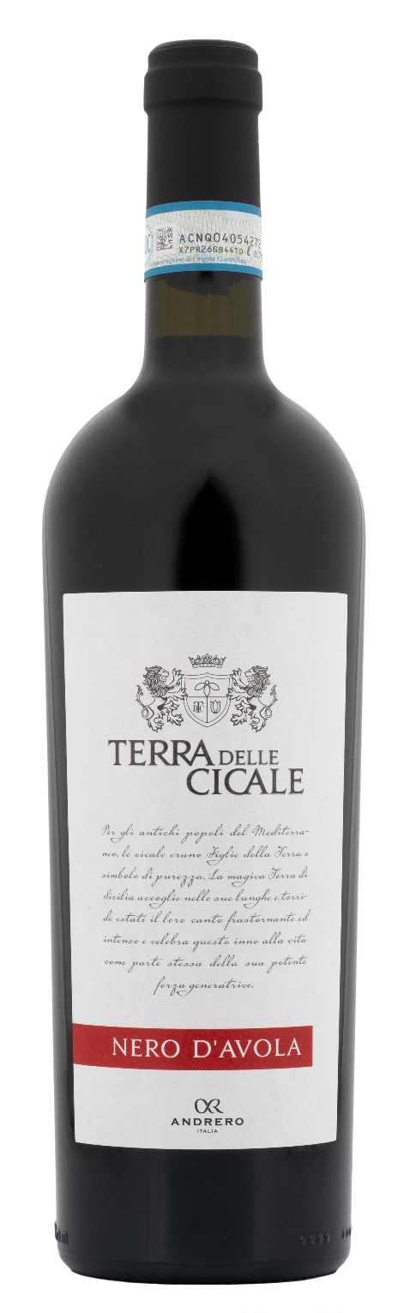
TECHNICAL INFORMATION / PALLETIZING

Size 750ml:
Article Nr. V11001A
GTIN-13 bottle 8017868001317
GTIN-13 carton 8017868004202
Closure Cork
Bottles / carton 6 bottles
Pallet size 80x120cm
Cartons/layer 21
Cartons/pallet 105
Kg/carton 7,8
Kg/pallet 845

Size 1500ml:
Article Nr. V11002B
GTIN-13 bottle 8017868001331
GTIN-13 carton 8017868004554
Closure Screwcap
Bottles / carton 6 bottles
Pallet size 80x120cm
Cartons/layer 14
Cartons/pallet 56
Kg/carton 13,5
Kg/pallet 780

Contains sulphites
GMO Free
Revisione 01. 10.05.2024

